如您未能閱讀此電郵，請[按此](https://vod.um.edu.mo/ipr/mp4/2025_UMCNY.mp4)  
If you cannot view this email, please [click here](https://vod.um.edu.mo/ipr/mp4/2025_UMCNY.mp4)

[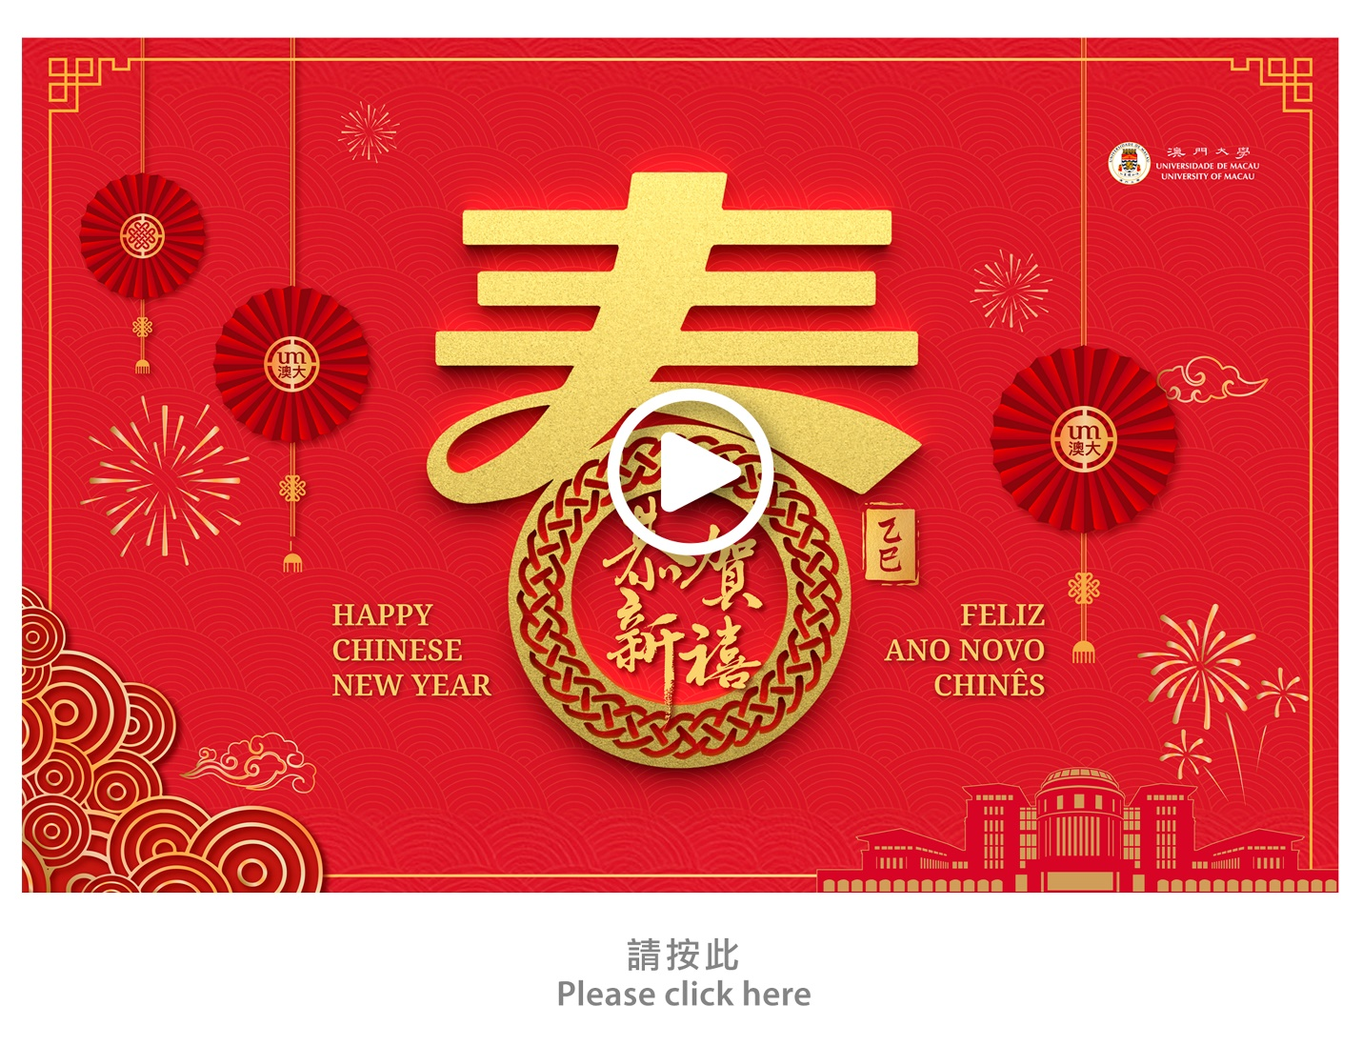](https://vod.um.edu.mo/ipr/mp4/2025_UMCNY.mp4)